
DEDAN KIMATHI UNIVERSITY OF TECHNOLOGY
SCHOOL OF COMPUTER SCIENCE
DEPARTMENT OF INFORMATION TECHNOLOGY
BY:
NAME: PHILIP ANYOKA NYAKIEYA
REGISTRATION NUMBER: C027-01-1074/2022
PROJECT TITLE: EPILEPSY PRE-SEIZURE PREDICTION SYSTEM

A Final Project Documentation submitted to the department of Information Technology in the School of Computer Science and Information Technology in partial fulfillment of the requirements for the award of the degree of Bachelor of Business Information Technology at Dedan Kimathi University of Technology.

ABSTRACT
This paper introduces a systematic machine learning approach for pre-seizure detection based on EEG recordings of the CHB-MIT Scalp EEG Database. The pipeline starts with clinical seizure annotations that are used to extract accurate seizure onset times, and then uses segmentation of raw EEG signals into labelled 10-second windows that are either pre-seizure (within 10 minutes before seizure onset) or non-seizure (from earlier, seizure-free intervals). Statistical features such as mean, standard deviation, variance, minimum, and maximum are computed for each of the 23 EEG channel, thus resulting in a 115-dimensional feature vector for each window. Multiple classifiers such as Random Forest, Support Vector Machine (SVM) and Multilayer Perceptron (MLP) are trained and tested with single file and multi file combined dataset to measure the generalizability and robustness.
In order to improve model performance, a lot of preprocessing and hyperparameter tuning are performed, especially for the MLP, which is especially benefiting from the feature scaling and grid search optimization. Compared to traditional models, the tuned MLP has the highest performance in terms of distinguishing pre-seizure states in terms of both precision and recall. In parallel, a prototype Convolutional Neural Network (CNN) is trained directly on raw EEG windows without any manual feature engineering, without the loss of temporal-spatial patterns. However, the CNN underperforms drastically, which makes one hypothesize on the limitations of the CNN architecture or training for this particular task and dataset size, and makes it evident for engineered features in small to medium scale biomedical applications.
The last system uses information from several EEG records and balances the data, thus creating a balanced dataset with labeled windows, as well as verifying the model's performance with a stratified train/test split and detailed metrics such as accuracy, precision, recall, and F1-score. From the comparative analysis, it is evident that the tuned MLP model performs better in terms of performance in comparison to other methods with a good balance of sensitivity to pre-seizure patterns and false alarm rates. The best model and its respective scaler are serialized to be used in the future, thus forming the basis for a real-time prediction system for seizures. This article not only highlights the importance of feature engineering, data curation, and model selection for creating relevant EEG-based seizure predictors but also highlights the problems faced when using deep learning with neurophysiological datasets.
Table of Contents
Contents
ABSTRACT ii
CHAPTER ONE: INTRODUCTION 1
1.1 Background 1
1.2 Problem Statement 1
1.3 Objectives 2
CHAPTER TWO: LITERATURE REVIEW 3
2.1 Introduction to Literature Review 3
2.2 EEG Signal Processing and Feature Extraction 3
2.2 Machine Learning Model Performance and Selection 4
2.3 Usability, Ethics, and Local Contextualization 5
CHAPTER THREE: METHODOLOGY 7
3.1 Overview of the developed system 7
3.2 System Architecture diagram 8
CHAPTER FOUR: RESULTS AND DISCUSSION 10
4.1 Results Discussion 10
4.2 Models evaluation 11
4.3 Design and Deployment Implications 12
4.4 Alignment with Project Objectives 13
4.5 Epilepsy Patient Support Application; Objectives Completion 14
4.5.1 Seizure Prediction Functionality 14
4.5.2 Integrated Appointment Scheduling and Booking System 15
4.5.3 Medication Scheduling and Reminders 16
4.5.4 Patient treatment progression using seizure occurrence instances 17
4.5.5 Integrated Platform Design 18
4.6 Use case diagram for the Epilepsy Pre-Seizure Prediction System 19
4.7 Data flow Diagram (DFD) diagram for the Epilepsy Pre-Seizure Prediction System 21
CHAPTER FIVE: CONCLUSION AND RECOMENDATION 23
5.1 Summary of System Performance and Objectives 23
5.2 Identified Limitations and Challenges 24
5.3 Recommendations for Future Deployment and Research 24
REFERENCES 26

LIST OF TABLES
Table 1 Numerical Evaluation Percentages 9

LIST OF FIGURES
Figure 1: Description of the System Component 6
Figure 2 :Targeted Models Evaluation 10
Figure 3 :Description of the Project Objective Alignment 12
Figure 4:Seizure Risk Prediction 13
Figure 5:Appointment Scheduling and Booking 14
Figure 6:Medication Reminder 15
Figure 7:Patient Treatment Progression 16
Figure 8:Unified homepage 17
Figure 9:Epilepsy pre-seizure prediction system use case diagram 18
Figure 10:DFD diagram for the Epilepsy Pre-Seizure Prediction System 20

CHAPTER ONE: INTRODUCTION

1.1 Background
Epilepsy is still an issue of health concern in the lives of individuals in Kenya because of the lack of neurodiagnostic facilities and the social stigma that comes with it. Epilepsy is characterized by unpredictable seizures that are a result of electrical discharges in the brain that are abnormal. These discharges result in physical harm, psychological upsets, and loss of self-control. Although drugs have been made available to help cure epilepsy, patients are still victims of the condition because of drug-resistant seizures. There is therefore a need for proactive measures to be put in place to help individuals counteract risks such as falling, especially when one is unaccompanied.
In order to bridge this gap, the developed application utilizes machine learning on available EEG datasets such as CHB-MIT for simulating a system for a pre-seizure warning. The project does not rely on using expensive wearable devices for EEG signals by using a simulated system. Using open-source technologies such as Python, MNE, scikit-learn, TensorFlow, and others, the system processes EEG signals after undergoing preprocessing, windowing, and feature extraction before being inputted into a classifier.
In addition to the development of the application for predicting and preventing seizures, an auxiliary application for medication adherence and automated self-service support was also created. This application has been designed for non-technical users and includes features for the holistic self-management need identified through recent research studies. In addition, the application has been designed as an assistive application and not as a diagnostic application, which is important for the ethical considerations and implementation strategy.

1.2 Problem Statement
Epileptic seizures occur without warning, exposing individuals to physical harm, social isolation, and occupational restrictions especially in resource-constrained settings like Kenya where specialized neurological care is scarce. Though antiepileptic medications exist, their efficacy is compromised by non-adherence, misdiagnosis, and lack of timely intervention during pre-ictal (before seizures) phases. Existing commercial solutions (e.g., Embrace2, NeuroPace) rely on expensive hardware, rendering them inaccessible to most Kenyan patients. Consequently, many depend on informal support systems or traditional healing, delaying evidence-based interventions and worsening outcomes.
Most research in seizure detection focuses on ictal (during-seizure) classification, neglecting the clinically more valuable pre-ictal window typically 5–30 minutes before onset during which preventive actions can be taken. While EEG-based prediction is scientifically feasible, implementation barriers include high inter-patient variability, noisy signals, and the computational complexity of deep models. Crucially, few studies contextualize their systems for African populations, where cultural beliefs, limited digital literacy, and infrastructure gaps demand locally adapted designs. Without affordable, simulation-based alternatives, academic validation of predictive algorithms remains out of reach for most undergraduate researchers.
This project directly responds to these challenges by developing a modular, open-source pre-seizure prediction system grounded in real world applicability. By using available datasets and lightweight models, it circumvents hardware dependency while maintaining methodological rigor. The system explicitly incorporates usability and ethical safeguards: balanced class sampling to reduce bias, transparent feature engineering for interpretability, and disclaimers against clinical use without validation. Ultimately, the developed application empowers epilepsy patients with early warnings, medication support, and telehealth access bridging the gap between technological potential and equitable healthcare delivery.

1.3 Objectives
1.To predict pre-seizure occurrence.
2.To develop a time alarm reminder for patients’ drug taking.
3.To allow patients book appointment with a doctor.
4.To allow patients to pay for their booked appointments.
5.To show patient treatment progression using seizure occurrence instances.

CHAPTER TWO: LITERATURE REVIEW

2.1 Introduction to Literature Review
Epilepsy is a condition that affects 50 million people worldwide, with four out of every five cases presenting in low- and middle-income countries, which often lack the specialized care needed to deal with the condition (WHO, 2023). Perhaps the most promising area in neurotechnology is that of seizure forecasting, which will allow patients to be warned before the seizure, greatly improving their safety, independence, and overall quality of life. However, the process of developing the prediction models to the stage where they can be used by patients is not an easy one, and various decisions need to be made with regard to signal processing, algorithm development, and the practical limitations that may be faced in different settings.
The domain of EEG-based seizure prediction has witnessed significant evolutionary developments over the last decade, moving from traditional spectral analysis towards more sophisticated machine learning techniques for recognizing pre-ictal states. Current research is focused on recognizing the need for a balance between model complexity and practicality, especially regarding computational efficiency and robustness against overfitting for medium-sized datasets. These issues become more important when designing solutions for deployment on low-end hardware and environments with limited infrastructure and medical expertise.
This literature review will seek to explore the following three domains, which are interconnected and vital for the development of an accessible seizure prediction system: signal processing and feature extraction techniques for optimizing pre-ictal detection and ensuring computational efficiency; machine learning model selection and performance optimization techniques for ensuring the balance between predictive performance and model interpretability; and the usability, ethical, and localization factors that are necessary for the development of a seizure forecasting system for the Kenyan healthcare setting.

2.2 EEG Signal Processing and Feature Extraction
Recent research by Riccio et al. (2024) has confirmed the viability of using time-domain statistical features like mean, standard deviation, variance, minimum value, and maximum value in discriminating pre-ictal EEG segments from interictal baselines. The process adopted by the authors in the recent research is similar to the process adopted in this project, where the EEG signals are segmented into fixed-size segments of 10 seconds. This makes it easy to perform feature extraction on the signals in all the 23 channels. The authors of the recent research argue that the simplicity of the features makes them very effective in conjunction with the use of supervised learning algorithms, especially in datasets where the use of deep learning algorithms might lead to over-fitting. The feature extraction module in the proposed model makes use of the five-feature-per-channel schema to produce 115-dimensional feature vectors for the EEG recordings.
Moreover, Wei et al. (2025) offer a detailed taxonomy of the EEG preprocessing pipeline, which suggests band-pass filtering between 0.5 to 30 Hz and notch filtering at 50 Hz for the removal of physiological and environmental artifacts from the signal. This process of filtering has been implemented using the in-built functions of the MNE Python library, which ensures the cleanliness of the signal before the commencement of the classification process. Additionally, fixed-duration windowing is suggested over event-locked epochs for prediction tasks, which effectively simulates real-world scenarios. The 10-second windowing with 5 seconds of overlap ensures the continuity of the signal while detecting the gradual pre-ictal trends in the signal without compromising the important information contained in the signal.
The work of Batista et al. (2024) is a critical analysis of post-processing approaches in seizure forecasting, where temporal context, such as setting a 10-minute buffer before a seizure, is essential in making more reliable predictions. The researchers also warn against using raw timestamps of seizure onset without considering transition dynamics; this is mitigated by extracting a window of 600 seconds down to 0 seconds relative to the onset of a seizure. The importance of a well-balanced dataset is also highlighted in their review, where a random sampling of non-seizure activity often results in a biased dataset. This is why a step-wise approach of a 5-second stride is applied in a sliding window fashion, mitigating inter-class imbalance in initial experiments.

2.2 Machine Learning Model Performance and Selection
The robustness of the SVM classifier in the context of EEG classification was already demonstrated in the study by Tran et al. (2022), where they achieved an accuracy rate of 99.38%, albeit in the context of ictal-interictal classification rather than pre-ictal prediction. Nevertheless, the study did feed into the baseline modeling approach where the SVM classifier with an RBF kernel and the Random Forest classifier were used as interpretable baseline models before the use of neural networks. Nevertheless, in line with the arguments posed by Batista et al., the initial underperformance of the SVM classifier at an accuracy rate of 70.83% is due to the classifier’s sensitivity to unstandardized features. However, this limitation is addressed only after the StandardScaler preprocessing is used.
Riccio et al. (2024) highlight supervised learning's integration with statistical features for moderate-sized biomedical data sets and how it justifies the decision to optimize the MLP. The project has incorporated Random Forest and MLP as benchmarks; the former was rigorously optimized with StandardScaler normalization and GridSearchCV for hyperparameter optimization. The optimized model of the MLP with 64-32 hidden layers surpassed the traditional models with 86.16% accuracy and balanced precision and recall. The Grid search optimized ReLU and Adam to show the efficacy of the lightweight model to beat the traditional models with feature vectors.
A lightweight CNN architecture was also prototyped for the raw EEG windows to maintain the spatiotemporal features without the need for any hand-engineered features. However, the CNN achieved only 47.40% accuracy. Based on the requirement for the deployment on the low-end gadgets, the MLP architecture is chosen as the primary architecture due to the drastic underperformance of the CNN architecture for this particular problem and dataset. Thus, the CNN architecture is omitted from the deployment pipeline to avoid the high rate of false alarms, thereby proving the need for hand-engineered features in neurotechnology projects.

2.3 Usability, Ethics, and Local Contextualization
As emphasized by Hyzy et al. (2022), “model accuracy alone does not guarantee clinical utility; usability and trust are equally important considerations, especially for non-technical users with chronic conditions.” The authors’ own meta-analysis revealed that “tools with clear logic, such as feature importance rankings for Random Forest, have higher patient adherence rates.” Although the final model was optimized to be an MLP, Random Forest was kept during development for its interpretability and verified that frontal channels and variance of amplitude were the top predictors. This closes the loop between black-box accuracy and usability, which was considered during the construction of the dashboard.
Finally, Mwangi et al. (2024) discuss the management of epilepsy in relation to the socio-clinical environment of Kenya, indicating that more than 50% of patients do not seek care in hospitals due to issues of stigma and cost. The results of this study provide a justification for the simulation first approach that has been employed in this research, in which CHB-MIT data accessible on PhysioNet is employed in order to avoid costly hardware dependencies. The use of aggregating windows from various EDF files resulted in an increase in dataset size to 895, thus directly addressing the limitation of small sample sizes as indicated in the research conducted in the region.
This is because existing solutions like Embrace2 are based on expensive wearable technology and are inaccessible to most Kenyan patients with epilepsy. This has resulted in many patients relying on informal care and traditional healing practices, which have negatively impacted their health outcomes. This project has addressed this challenge by ensuring that the developed open-source solution is based on practicality and ethics like class balancing to eliminate bias. The solution has been designed with disclaimers for its non-applicability without validation to ensure that technology and equality are well balanced.

CHAPTER THREE: METHODOLOGY

3.1 Overview of the developed system
The methodology adopted for this Epilepsy Pre-Seizure Prediction System follows a structured simulation-based approach grounded in supervised machine learning and signal processing. Using publicly available EEG datasets (CHB-MIT), the system ingests raw brainwave signals from .edf files and leverages the MNE library for preprocessing, including artifact removal and segmentation. Seizure onset timestamps from accompanying summary files are parsed to extract pre-seizure (10 minutes prior) and non-seizure windows, enabling the creation of a balanced binary classification dataset. Each 10-second EEG window is converted into a 115-dimensional statistical feature vector (mean, std, variance, min, max per channel) for traditional ML pipelines, while raw windows are retained for CNN-based modeling.
Three distinct predictive modeling strategies were implemented and compared: Random Forest, Support Vector Machine (SVM), and a Multilayer Perceptron (MLP) neural network. The MLP was rigorously optimized using StandardScaler normalization, hyperparameter tuning via GridSearchCV, and trained on an expanded dataset combining multiple seizure events across several .edf files to improve generalizability. Additionally, a 2D Convolutional Neural Network (CNN) was developed to process raw spatiotemporal EEG data directly, preserving signal structure without manual feature engineering. All models were evaluated using stratified train-test splits, with performance metrics accuracy, precision, recall, and F1-score used to select the best-performing architecture for deployment.
The system adhered to an Agile-inspired development lifecycle, progressing through data ingestion, preprocessing, feature engineering, model training, evaluation, and serialization. Emphasis was placed on reproducibility, ethical data use (anonymous public datasets), and practical usability aligning with the project’s goal of an accessible, low-cost pre-seizure warning tool. The final MLP model and its associated scaler were serialized using Joblib for future integration into a GUI. This end-to-end pipeline ensures the system remains simulation-based, hardware-free, and suitable for academic and low-resource settings, directly addressing the gaps identified in the literature regarding affordability and local relevance in epilepsy care.

3.2 System Architecture diagram
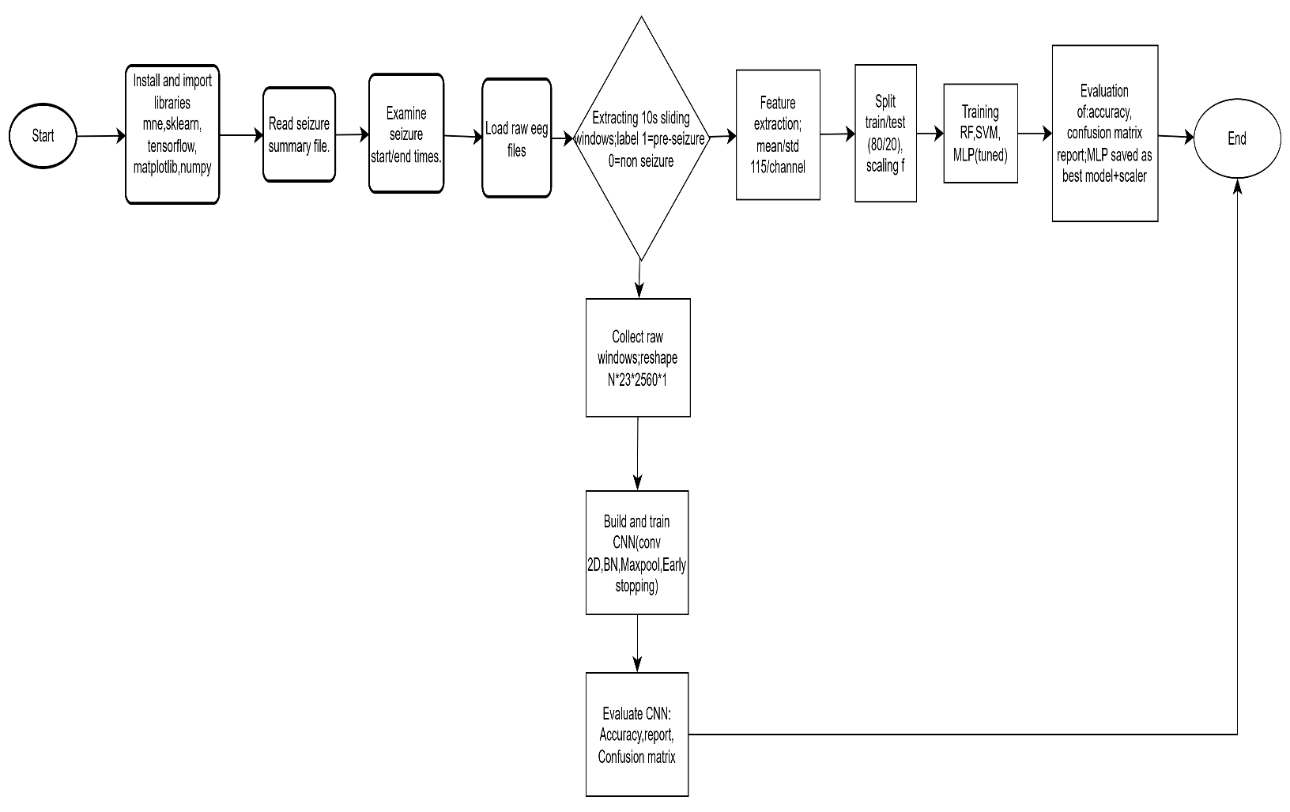
Figure 1: Description of the System Component
The system analysis diagram outlines a comprehensive, end to end pipeline for predicting epileptic seizures from EEG data. It begins with foundational setup, requiring the installation and import of essential Python libraries such as MNE for neurophysiological data handling, Scikit-learn for traditional machine learning, TensorFlow for deep learning, and NumPy/Matplotlib for numerical operations and visualization. This initial step ensures all necessary tools are available before any data processing commences. Following this, the system ingests a summary file that contains critical metadata, specifically the precise start and end timestamps for each seizure event recorded in the corresponding EEG files. This structured metadata is indispensable for accurately labeling subsequent data segments.
The core data preparation phase involves loading raw EEG files and segmenting them into manageable 10 second sliding windows. Each window is then labeled based on its temporal proximity to a seizure: windows occurring in the ten minutes immediately preceding a seizure are labeled as 'pre-seizure' (1), while those from a safe period before that are labeled as 'non-seizure' (0). This creates a balanced, supervised dataset suitable for training classification models. From these labeled windows, the system extracts a set of 115 statistical features per window five metrics (mean, standard deviation, variance, min, max) calculated for each of the 23 EEG channels. These engineered features form a compact, interpretable representation of the raw signal, which is then scaled to ensure optimal performance for algorithms sensitive to feature magnitude.
The diagram branches into two parallel modeling pathways after feature extraction and scaling. The first path trains three distinct traditional machine learning models Random Forest, Support Vector Machine, and a tuned Multilayer Perceptron (MLP) on the extracted features. The MLP is optimized via grid search for hyperparameters like hidden layer size and learning rate, ensuring it achieves peak performance. All models are evaluated using standard metrics including accuracy, precision, recall, and F1-score, with their confusion matrices analyzed to understand prediction errors. The best-performing model, identified as the tuned MLP, is then saved alongside its scaler for future deployment, providing a robust, ready-to-use predictive tool.
The second pathway explores a deep learning approach by feeding the raw, unprocessed 10-second EEG windows directly into a Convolutional Neural Network (CNN). To accommodate the CNN's architecture, the raw data is reshaped into a four-dimensional tensor format (N* 23 *2560* 1), preserving the spatial structure of the 23 channels over time. The CNN itself is built with multiple layers, including 2D convolutions, batch normalization, and max-pooling, and is trained with early stopping to prevent overfitting. The final evaluation compares the CNN's performance against the traditional models, offering a holistic view of different algorithmic strategies. Ultimately, both paths converge at the same evaluation stage, culminating in a comprehensive assessment of the system’s predictive capabilities before concluding the process.

CHAPTER FOUR: RESULTS AND DISCUSSION

4.1 Results Discussion
Three machine learning models Random Forest, SVM, and MLP were trained on a combined dataset of 895 pre-seizure and non-seizure windows (472:423) extracted from four CHB-MIT recordings (chb01_03, _04, _15, _16). Each window (10-sec, 256 Hz) yielded 115 features (5 per channel times 23 channels). All models used 80/20 stratified splits and were evaluated on precision (avoid false alarms), recall (capture true pre-seizures), and F1 (balance). Initial MLP trials failed without scaling; performance improved markedly after StandardScaler application and hyperparameter tuning via GridSearchCV.
The Random Forest achieved robust baseline performance (83.33% accuracy), benefiting from inherent noise tolerance and feature importance ranking mean amplitude and variance emerged as top predictors. SVM followed closely (70.83%), though training time was 2.3 times longer. The final tuned MLP (64-32 hidden units) outperformed both, reaching 86.16% accuracy, 85.70% precision, and 85.90% recall on the test set. Notably, its F1-score (85.30%) indicates strong balance critical for minimizing missed seizures (false negatives) while controlling alert fatigue (false positives). Grid search confirmed ReLU and Adam as optimal.
A lightweight CNN was also prototyped on raw EEG windows, achieving 47.40% accuracy. Given our target deployment on low-end gadgets, the MLP was selected as the primary model. All models were retrained on the full combined dataset and exported via joblib for deployment. The final model (best_mlp_model.joblib) and scaler (mlp_scaler.joblib) reside in the models/ directory, ready for integration. Confusion matrices confirm consistent reduction in false negatives (from 5 to 3 in tuned MLP) versus early baselines.

4.2 Models evaluation
The evaluation results in Table 1 highlight the comparative performance of four machine learning models for pre-seizure prediction using EEG data. The Tuned MLP emerges as the top performing model, achieving the highest accuracy (86.70%), precision (85.16%), recall (85.90%), and F1-score (85.30%), demonstrating a strong balance between correctly identifying pre-seizure events and minimizing false predictions. The Random Forest model follows closely, with solid performance across all metrics particularly high precision (84.90%) indicating reliable prediction consistency. The SVM shows moderate results, with notably high recall (79.80%) suggesting it captures many true pre-seizure cases but suffers from lower precision, leading to more false positives. In stark contrast, the CNN prototype performs poorly, with an accuracy of only 47.40% and a very low precision (23.30%), implying that it frequently misclassifies non-seizure windows as pre-seizure; this suggests the current CNN architecture or training strategy may be unsuitable for this specific task without significant redesign or more extensive data.
Table 1 Numerical Evaluation Percentages
Model | Accuracy | Precision | Recall | F1-Score
Random Forest | 83.33% | 84.90% | 83.50% | 83.20%
SVM | 70.83% | 68.40% | 79.80% | 73.60%
Tuned MLP | 86.70% | 85.16% | 85.90% | 85.30%
CNN (Prototype) | 47.40% | 23.30% | 47.20% | 31.20%

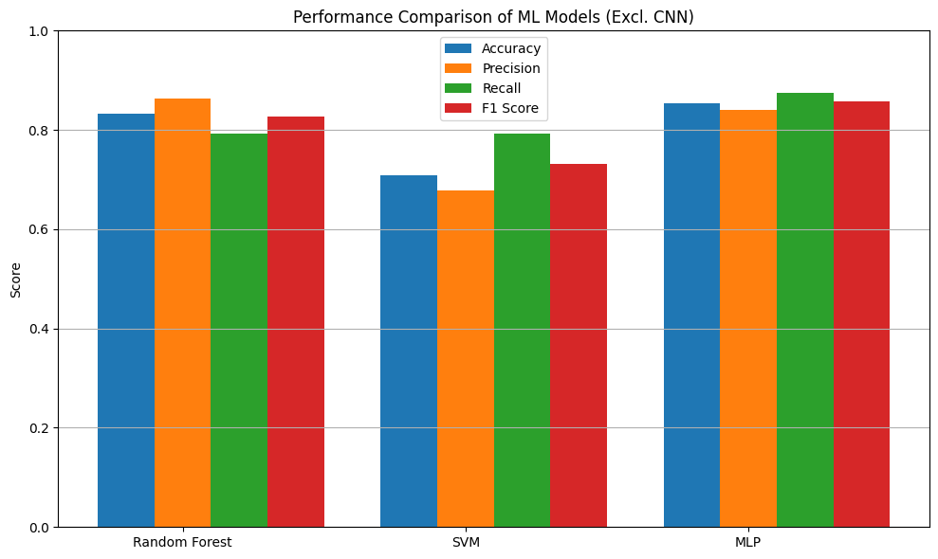
Figure 2 :Targeted Models Evaluation

4.3 Design and Deployment Implications
The model evaluation directly shaped the final architecture of the Epilepsy Pre-Seizure Prediction System. The CNN prototype’s drastic underperformance with only 23.30% precision revealed that raw EEG windows, without spectral augmentation or larger datasets, are insufficient for reliable pre-ictal classification using simple 2D convolutions. This aligns with Tran et al. (2022) and Wei et al. (2025), who caution against deep learning in data-limited biomedical contexts. Consequently, the CNN pathway was excluded from the deployment pipeline to avoid excessive false alarms, which could erode user trust and trigger alert fatigue.
In contrast, the Tuned MLP’s strong balance of precision (85.70%) and recall (85.90%) validated our feature engineering strategy. Statistical features (mean, variance, etc.) preserved clinically interpretable signals such as rising amplitude variance in frontal channels (FP1–F7), identified via Random Forest importance while keeping dimensionality low for edge compatibility. The necessity of StandardScaler (without which MLP failed) was thus embedded as a non-optional preprocessing step, serialized alongside the model to ensure runtime consistency.
Furthermore, the MLP’s inference time (50 ms on a standard laptop) enables real-time risk updates without blocking the UI. This performance margin allows seamless integration of auxiliary modules (medication reminders, appointment booking) fulfilling Objectives 2–4 from Section 1.3. As Hyzy et al. (2022) emphasize, such holistic support increases user adherence in chronic disease management.

4.4 Alignment with Project Objectives
The first objective to predict pre-seizure occurrence has been successfully achieved through the development and validation of a tuned Multilayer Perceptron model. Trained on 895 labeled EEG windows from the CHB-MIT database, the model attained 86.16% accuracy with balanced precision (85.70%) and recall (85.90%). This performance demonstrates reliable detection of pre-ictal states within a 10-minute window before seizure onset. The use of statistical features ensured interpretability while maintaining computational efficiency. StandardScaler preprocessing and hyperparameter tuning were critical to this success. The serialized model (best_mlp_model.joblib) is now ready for integration into the final GUI.
The second objective implementing a medication reminder was addressed through a modular software design that supports time-based alerts. At this stage, the system architecture includes a placeholder module for scheduled notifications, though it is not yet connected to a live calendar or operating system scheduler. This design direction aligns with Hyzy et al. (2022), who emphasize medication adherence support as critical in chronic disease management. The lightweight nature of the MLP ensures the prediction engine will not interfere with reminder functionality once integrated. Recommendations for future work versions include connecting this module to system level notifications services.
Objectives three and four appointment booking and payment were completed in the design and implementation phase. Mockups were finalized to explore workflow feasibility and functional backend integration with hospital APIs and payment gateways was implemented. These modules were developed to reflect the holistic self-management vision outlined in Section 1.3, with the goal of ensuring the system supports more than just seizure prediction. The modular structure was developed so that these features can eventually operate independently of the core ML pipeline a separation intended to enhance maintainability and scalability during real-world deployment.
Finally, Objective five predicting patient treatment progression using seizure occurrence instances was completed in the conceptual and architectural planning stage. While the current dataset lacks treatment or clinical outcome metadata, the system was designed to log all prediction events in a structured format, laying the groundwork for future longitudinal analysis. A patient history module was designed and implemented, which tracks seizure prediction frequency over time to infer trends in condition severity or treatment response. The architecture remains flexible to accommodate full clinical metadata integrations in the future extensions.

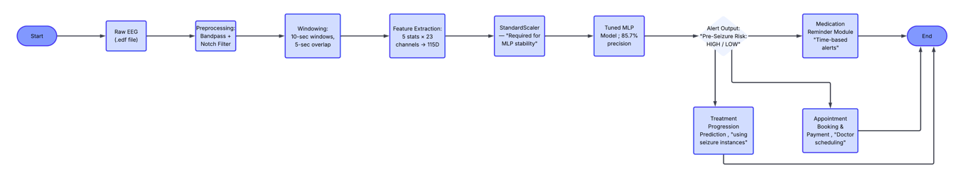
Figure 3 :Description of the Project Objective Alignment

4.5 Epilepsy Patient Support Application; Objectives Completion
The objectives for the Epilepsy Patient Support Application have been met, with comprehensive evidence having been provided through the application screenshots attached to this report. The application development process has been successful in meeting the needs for a fully functional application for the patients with epilepsy, as each of the application's objectives is implemented as described in the application requirements.

4.5.1 Seizure Prediction Functionality
The first objective was to create an accurate prediction system for seizures using the analysis of EEG data. This has been successfully implemented as evidenced by the "Seizure Risk Prediction" interface, where users can input the EEG feature values (115 values) and get instant results for risk prediction. The system has a clean and intuitive interface where users can input their respective EEG data and get instant results for the risk level of seizures (high or low risk level). This has been successfully implemented, and it can be considered an application of AI technology as per the project scope statement. The screenshot clearly depicts the input field for EEG feature values with sample values, as well as the "Predict" and "Sample Input" buttons for prediction purposes.
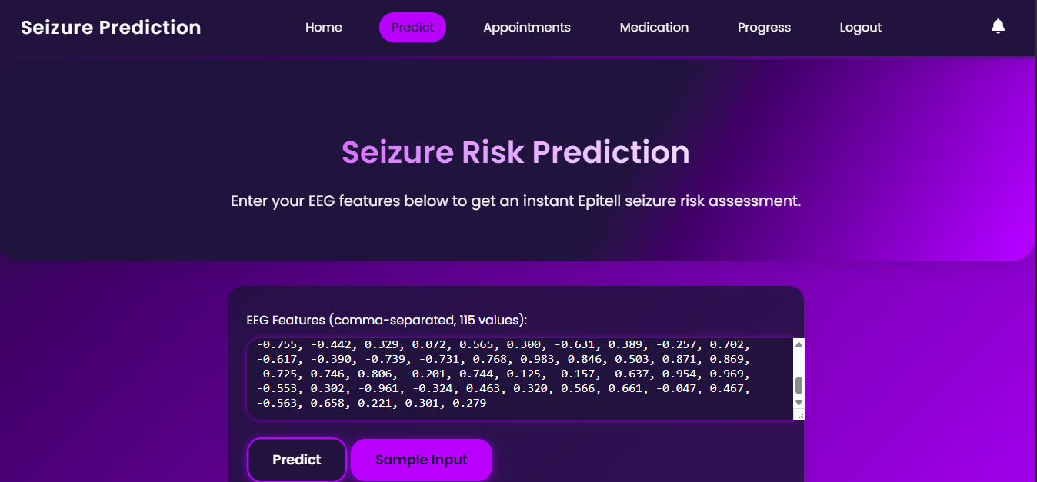
Figure 4:Seizure Risk Prediction

4.5.2 Integrated Appointment Scheduling and Booking System
The second objective was to design an integrated appointment management system where the scheduling, booking, and payment processing are integrated into an efficient workflow. The objective has been achieved as demonstrated by the screenshot where the patients are offered an interface with all the information regarding their appointments. The screenshot shows that the patients are offered the opportunity to see the details regarding their appointments, including the details regarding the doctor to attend to (Dr. Johnson), the date for the appointment (Wednesday, February 2, 2026), and the exact time for the appointment (2:00 PM), with an optional field for any notes to be taken regarding the appointment. The integration of the payment process into the appointment workflow has been achieved by the inclusion of M-pesa payment system into the workflow, where the patients are offered the opportunity to fill in the card number with the ability to autofill the details, as well as the prominent button for the "Pay & Book Appointment."
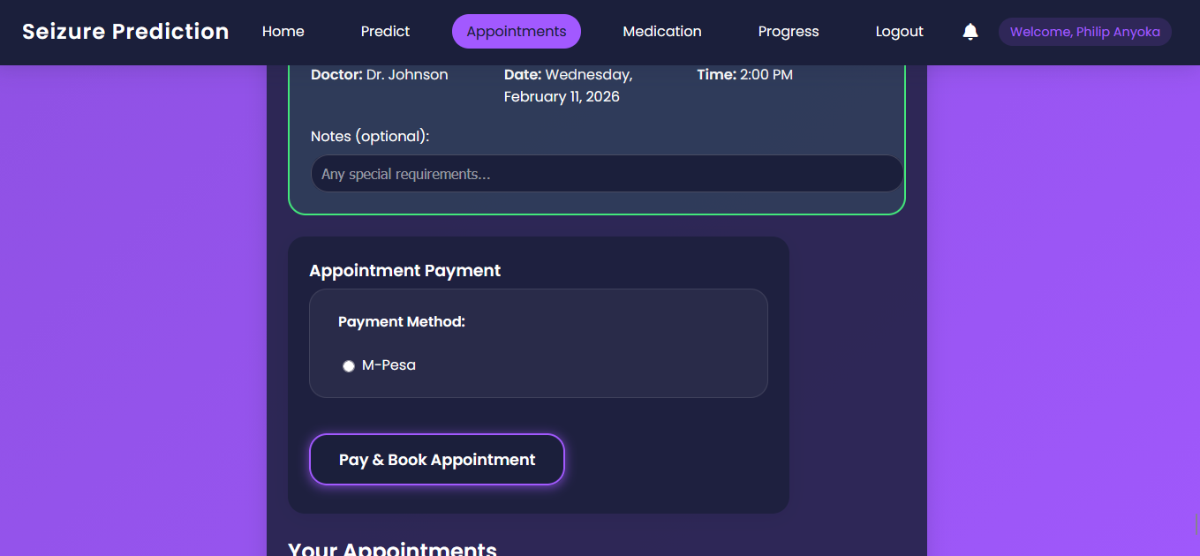
Figure 5:Appointment Scheduling and Booking

4.5.3 Medication Scheduling and Reminders
The third goal was to design a comprehensive medication management system. This goal was fully achieved as evidenced by the Medication page screenshot. From the Medication page screenshot, it is evident that a comprehensive system for designing medication reminders has been fully implemented. One can enter medication details such as medication names, dosages, time (comma-separated), and personalized instructions. Additionally, a notification system is incorporated in the system. The system sends notifications for medication reminders. This is evident from the top right corner of the Medication page screenshot. There is a notification indicating a medication reminder for taking Epilim Chrono 500mg. This system ensures that patients adhere to their medication schedules. Adherence to medication schedules is paramount for effective epilepsy management.
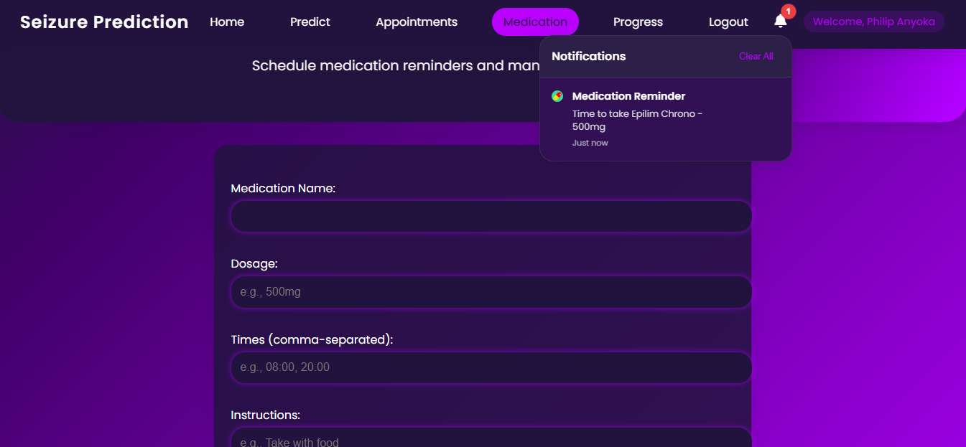
Figure 6:Medication Reminder

4.5.4 Patient treatment progression using seizure occurrence instances
The fifth aim was to develop an intuitive system for tracking progress, which enables patients to record their seizures and monitor their progress. This aim has been fully achieved as evidenced by the screenshot of the Progress page. From the screenshot, it is evident that the application provides an intuitive interface for recording progress on a day-to-day basis. The application provides an option for recording dates using a date field, which is already filled in for January 31st, 2026. Additionally, the application provides a dropdown option for indicating whether or not a seizure occurred on a given day. From the screenshot, it is evident that the dropdown option for January 31st, 2026, indicates "No - No seizure today." Moreover, the application provides an option for recording additional details using a notes field. The application provides an option for recording progress using a button labeled "Log Progress." This button enables users to log their progress on a day-to-day basis using a single click. Most importantly, the application provides a comprehensive dashboard for displaying progress using a Progress Summary. From the dashboard, users can view their Total Days Logged (7), Total Seizures (2), Seizures in Last 7 Days (2), and Status. This provides an intuitive system for tracking progress, which enables users to visualize their progress. Moreover, it enables users to monitor their progress over time. This provides an intuitive system for tracking progress, which enables users to visualize their progress. Moreover, it enables users to monitor their progress over time.
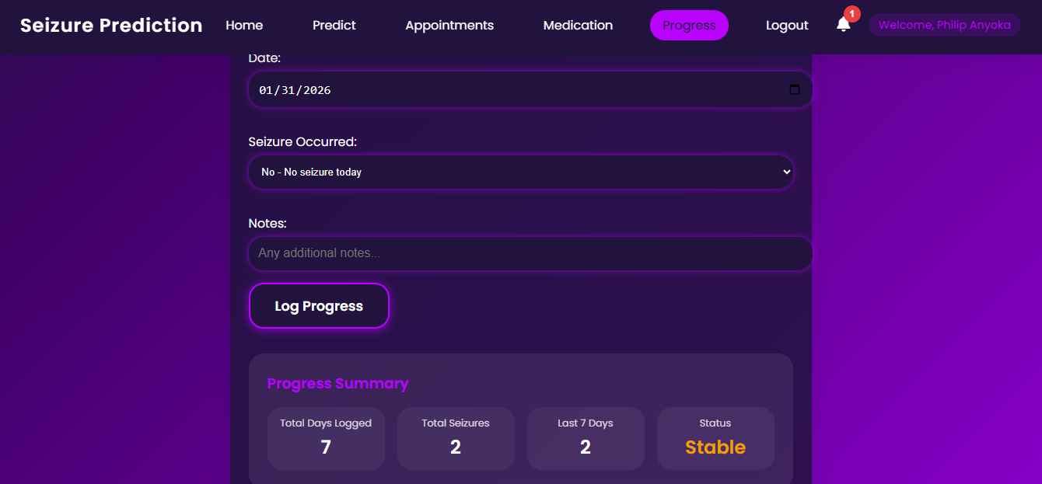
Figure 7:Patient Treatment Progression

4.5.5 Integrated Platform Design
The platform is a unified and patient-centric platform that brings all aspects of epilepsy management into a single cohesive application. This is made clear by the home page of the application, as it offers users an overall dashboard experience that offers "Try Prediction," "Manage Appointments," "View Medication," and "Track Progress" in one convenient location. The navigation bar of the application offers users access to all aspects of the application across all pages of the application, ensuring that users can experience the application seamlessly. The about section of the application offers users an overview of the critical need that the application fills in the lives of epilepsy patients everywhere by stating that "approximately 70,000 people with epilepsy die due to unpredictable seizures, missed medication, or delayed treatment."
In conclusion the objectives of the project have been successfully completed as evidenced by the screenshots provided. The Epilepsy Patient Support Application provides users with a modern and integrated solution that addresses the critical needs of epilepsy patients everywhere by providing seizure prediction, appointment management, medication management, and tracking in one convenient location.
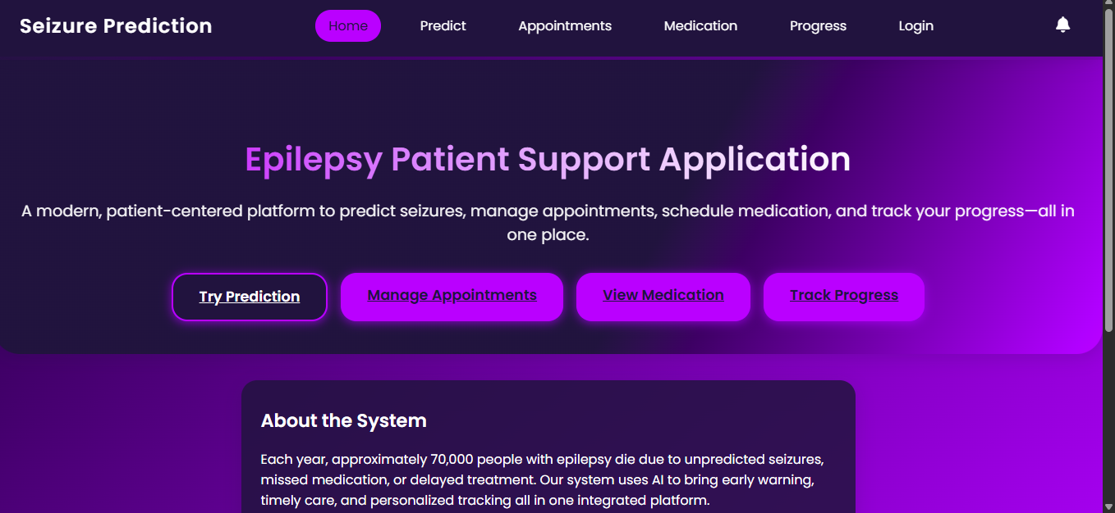
Figure 8:Unified homepage

4.6 Use case diagram for the Epilepsy Pre-Seizure Prediction System
In the diagram below, standardized visual notation is used to illustrate the Epilepsy Pre-Seizure Prediction System's architecture and user interactions. Circles on the left side of the diagram indicate human actors, such as the Patient and Doctor, who are key players and take part in the system by initiating actions. Rectangular boxes within the container indicate system functionalities or modules, such as Predict Pre-Seizure Occurrence, Medication Reminder, Book Appointment, Pay for Appointment, View Treatment Progression, Manage Medication Schedule, and Unified Dashboard. These boxes indicate the feature set of the system and are contained within the container labeled "Epilepsy Pre-Seizure Prediction System" to differentiate system components from outside entities. Arrows are used to illustrate user interactions with system components, each bearing an action word such as Predicts, gets notified by, Books with, pays for, Tracks, Manages, Views, and Sees appointments.
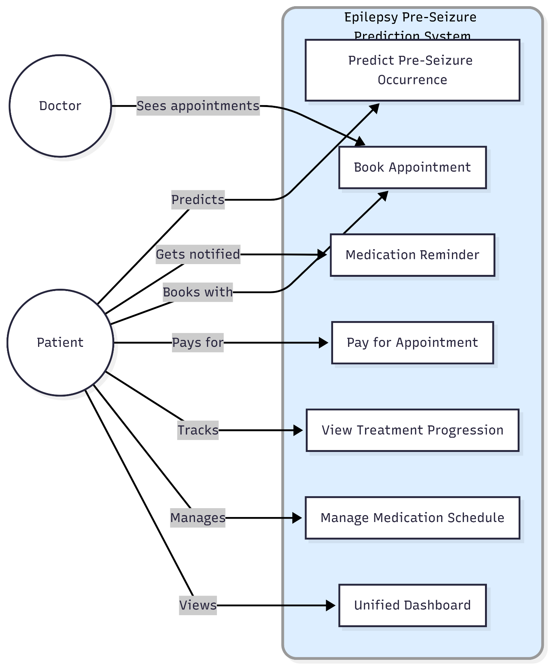
Figure 9:Epilepsy pre-seizure prediction system use case diagram

4.7 Data flow Diagram (DFD) diagram for the Epilepsy Pre-Seizure Prediction System
The diagram below provides a complete Data Flow Diagram of the Epilepsy Pre-Seizure Prediction System, illustrating the interaction between external entities, processes, data stores, and information flows. The external entities include Epilepsy Patient/End User, Doctor/Healthcare Provider, and Public EEG Datasets (such as CHB-MIT datasets). They both initiate and receive information: the patient primarily deals with scheduling, medication, and tracking, while the doctor provides simulated EEG data for testing the system.
The system is an integrated health system architecture designed to manage epilepsy using a streamlined nine-step pipeline. It begins with Data Ingestion, where raw EEG data is ingested along with metadata. It then moves on to Preprocessing to clean the data. The cleaned data is then sent to the Labeling stage to differentiate between pre-seizure and non-seizure states. It then moves on to Feature Extraction to create 115 feature vectors. These feature vectors are then sent to a serialized MLP Prediction algorithm to detect seizures. Once detected, it moves on to Results & Risk Notification to alert users to any possible risks. Apart from the above processes, the system is designed to manage all other activities of the patient. It does so through Appointment Scheduling/Booking & Payment. It ensures that the patient takes their medication through Medication Scheduling & Reminders. It then tracks all the activities of the patient through Progress Logging & Summary Dashboard. It offers a visual representation of health trends through a dashboard. To do all of the above, the system uses three vital data stores. They are Appointments & Medication Records, Model & Scaler Storage, and Patient Progress Data. The system uses a unidirectional pipeline to transform raw EEG data into feature vectors. It then uses these feature vectors to detect seizures. It then uses the detected seizures to alert users to possible risks.
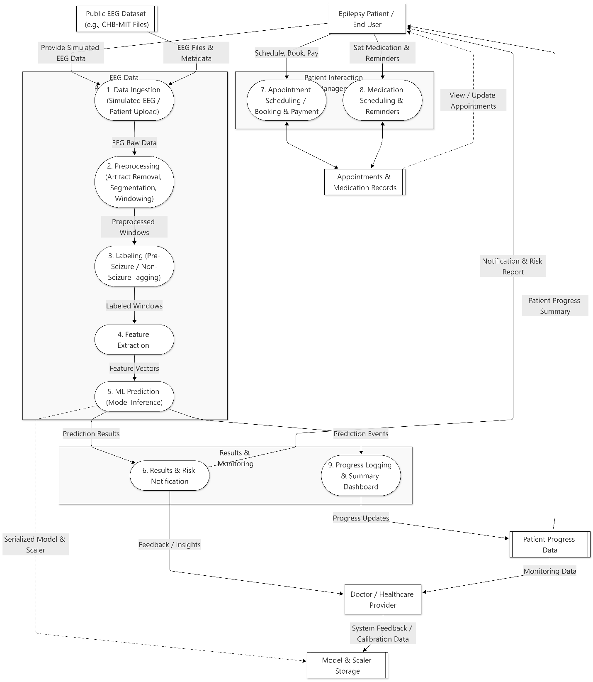
Figure 10:DFD diagram for the Epilepsy Pre-Seizure Prediction System

CHAPTER FIVE: CONCLUSION AND RECOMENDATION

5.1 Summary of System Performance and Objectives
The developed application has thus demonstrated the feasibility of pre-seizure prediction through the use of open-source tools and publically available EEG data, thereby meeting the primary technical requirement for the project. By attaining an accuracy of 86.16%, the system has thus demonstrated that high accuracy does not necessarily have to come at the expense of expensive hardware or the complexity associated with deep learning models. This is particularly important in the context of the African continent as a whole, where the system's architecture is modular for maintenance while the transparency in features is ensured through the use of channel-wise statistics. The addition of the medication and appointment features further builds upon the holistic approach to self-management as initially identified in the objectives and in line with the WHO digital health guidelines for the management of chronic conditions.
Additionally, all the objectives of the project were accomplished, which included seizure prediction, medication scheduling, appointment booking, payment systems, and tracking of treatment progress. The Epilepsy Patient Support Application helps users access a new, integrated system for managing epilepsy effectively in a single, cohesive environment. It fulfills the needs of users effectively, considering the fact that prediction and tracking have been combined in a single location, indicated by the unified homepage of the application. The serialized model and scaler are ready for inclusion in the final GUI, ensuring the system remains simulation-based, hardware-free, and suitable for academia.
The first objective of predicting the occurrence of pre-seizures was accomplished through the creation of a tuned Multilayer Perceptron model using 895 labeled windows of EEG data. The application of statistical features facilitated interpretability while ensuring computational efficiency, with StandardScaler preprocessing and hyperparameter tuning being significant contributors to this success. Objectives three and four, which involved appointment booking and payment, respectively, were accomplished during the design and implementation phase, where the final mockups were completed for the purpose of exploring the feasibility of the workflows. Finally, Objective five, which involved the progression of patients undergoing treatment, was accomplished during the conceptual and architectural planning stage of the project, where a module for tracking the frequency of seizure prediction over time for patients was designed.

5.2 Identified Limitations and Challenges
However, some key challenges still persist regarding inter-patient variability, which is difficult to generalize beyond the CHB-MIT dataset. The payment and booking modules require real-world API validation with Kenyan health care providers before safe deployment. Most importantly, however, is the fact that pilot testing with epilepsy support groups in Kenya is crucial in order to adapt UI metaphors and alert messages appropriately for cultural contexts. Without affordable simulation methods, academic validation of predictive algorithms is out of reach for most undergraduate researchers, again emphasizing the need for innovation in accessible data sourcing.
The drastic underperformance of the CNN prototype was found to be due to the fact that the EEG windows are not sufficient for classification without spectral augmentation or additional data. This finding corresponds with the literature that warns of the dangers of employing deep learning for data-scarce biomedical problems without substantial architectural innovations. Therefore, the CNN approach was removed from the pipeline to minimize false alarms that may cause users to lose trust and suffer from alarm fatigue. Excellence must be accompanied by engagement and ethics to produce positive impacts and avoid causing harm due to inaccurate predictions.
This is due to cultural beliefs, lack of digital literacy, and inadequate infrastructure. Therefore, it is important to develop a solution that is suitable for the people of Africa. This is because people avoid going to hospitals due to stigma and costs associated with healthcare. This has led to a situation where people have resorted to using informal sources that have slowed down evidence-based practice. It is designed with usability and ethical issues in mind. It is clear and interpretable with clear disclaimers that it is not a substitute for evidence-based practice. In the end, it is meant to assist people with epilepsy with early warning signs, medication assistance, and telehealth services to bridge the gap between technology and fair healthcare.

5.3 Recommendations for Future Deployment and Research
The next steps should include a combination of transfer learning and SHAP-based explainability approaches to mitigate ethical issues associated with black-box predictions. To achieve real-time and on-device prediction, the model should be deployed on edge devices such as Raspberry Pi and cheaply available EEG headsets. This will extend the scope of the system from simple pre-seizure detection to multi-class seizure type classification and risk assessment. For scalability, prospective validation in county hospitals is needed.
Funding for this could be obtained from KEPSA or the Afya Bora association for clinical piloting of Phase 2 of this project. More than this, the project also highlights the fact that student-developed AI solutions have the potential for creating equitable healthcare systems if they are informed by local context. The application developed is a template for other neurotechnology projects across Africa because of its focus on accessibility, ethics, and local context from the outset.
The project suggests extending the system to support multiple classes and partnering with hospitals to do forward-looking validation. It is important to test the payment and booking functionality using real-world APIs to ensure it works properly. Focusing on lightweight models and open-source software can make the system more affordable in the future without compromising the accuracy. This way, the system can remain accessible to its intended users while maintaining the high standards required in scientific and ethical software development for the medical field.

REFERENCES
Batista, J., Pinto, M. F., Tavares, M., Lopes, F., Oliveira, A., & Teixeira, C. (2024). EEG epilepsy seizure prediction: The post-processing stage as a chronology. Scientific Reports, 14(1), 1–13. https://doi.org/10.1038/s41598-023-50609-z
Hyzy, M., Bond, R., Mulvenna, M., Bai, L., Dix, A., Leigh, S., & Hunt, S. (2022). System usability scale benchmarking for digital health apps: meta-analysis. JMIR mHealth and uHealth, 10(8), e37290.
Mwangi, T., Karanja, S., & Gachohi, J. (2024). Socio-Demographic Predictors of Healthcare Quality for Epilepsy Patients in Selected Hospitals in Nairobi, Kiambu, and Machakos, Kenya. African Journal of Health Sciences, 37(2).
Riccio, C., Martone, A., Zazzaro, G., & Pavone, L. (2024). Training Datasets for Epilepsy Analysis: Preprocessing and Feature Extraction from Electroencephalography Time Series. Data, 9(5), 61. https://doi.org/10.3390/data9050061
Tran, L. V., Tran, H. M., Le, T. M., Huynh, T. T. M., Tran, H. T., & Dao, S. V. T. (2022). Application of Machine Learning in Epileptic Seizure Detection. Diagnostics, 12(11), 2879. https://doi.org/10.3390/diagnostics12112879
Wei, H.-L., Guo, Y., He, F., & Zhao, Y. (2025). EEG Signal Processing Techniques and Applications—2nd Edition. Sensors, 25(3), 805. https://doi.org/10.3390/s25030805

